**Business Focussed Form Design Document**

**Prepared for:**

**CHAS**

**Document Control**

|  |  |  |  |
| --- | --- | --- | --- |
| Version | Reason for Change | Changed By | Date of Change |
| 0.1 | Created | David Olle | 01/02/2022 |
|  |  |  |  |
|  |  |  |  |
|  |  |  |  |

**Distribution List**

|  |  |  |
| --- | --- | --- |
| Name | Title | Date Issued |
|  |  |  |
|  |  |  |
|  |  |  |
|  |  |  |
|  |  |  |
|  |  |  |

Table of Contents

1. Introduction 4

1.1. Form Design 4

1.2. Contacts 4

1.3. Accounts 5

1.4. Connections 6

1.5. Sales Products and Families 7

1.6. Opportunities 8

1.7. Leads 9

1.8. Activities 9

1.9. Navigation 10

1.10. Universal & Relevance Search 11

1.11. Business Process Flows 12

2. Summary 14

3. Appendices 15

# Introduction

This document covers the updated customizations made in the new Dynamics 365 environments.

The objective is to show the customizations made to all core entities in the new Sales CRM environments including the one made to:

* Accounts
* Contacts
* Opportunity
* Sales Order
* Lead

## Form Design

This shows the Dynamics 365 user interface forms for each entity which present the necessary information in a logical order which aligns with the sales team’s processes.

## Contacts

Figure 1: Example Contact Form

The above is an example contact form that could be used by CHAS to review contact information.

Basic information such as Contact Information (email address, telephone number exc.) can be stored in the Summary tab as well as Lookup to Contact’s respective Customer Type data to indicate whether Contact is either a Contract or Client.

Membership details is now located under the Product tab. This allows CHAS Telesales and BDMs to view immediately the relevant information for them for sales activity.

## Accounts

Account information is recorded in Dynamics 365, and these can be updated with fields, forms, layouts etc, as necessary. The key attributes to the account entity are viewing information that is relevant to Sales teams such as who the client is, what membership type they have with CHAS (and the details of that membership) and the number of sub-contractors that the account may have. This enables Telesales teams to quickly identify whom they are speaking with as calls come in from prospective customers, they can easily navigate and see relevant information on the account form.

Figure 2: Example Account Form

## Leads

Leads is an entity used when little information is known about a customer and hence there is a need to capture this so that a Sales team member can follow up with a potential customer. Lead forms as above tend to be basic in nature entering in only critical information known at a given stage.

CHAS can generate leads can be generated in a variety of ways i.e. website form fills etc. which can be created as leads and then “Qualified” onto becoming an Opportunity for Sales to follow through the sales process.

Figure 3: Example Lead form

## Opportunities

Figure 4: Example Opportunity form

The Opportunity form can be utilised by both CHAS Telesales and BDM’s to manage and track opportunity engagement throughout its lifecycle. Ensuring a streamlined sales process through a business process flow which tracks where in the Sales lifecycle a customer may be and how long they have been in a particular stage of the opportunity funnel. For streamlined and unified Sales process across CHAS organisation.

Further to this, summary details can easily be seen including whom the client is, and what sales channel they came through to CHAS. In addition, stakeholders and their role on the opportunity can be viewed, including connections to other contractors and/or if the contractor is part of a wider client group.

Tabs can be used across the opportunity to detail what product/assessments have been made or any quotes that may have been generated for the customer from the Portal. When opportunity is then won the order can be automatically created and sent to membership service team to processes.

## Order

Figure 5: Example ORDER form

The Order form is used to store details of the order post a won opportunity.

The summary tab contains details about Payment Amount, List of Products included in the order as well as the Opportunity and Customer Account related to that Order.

There is a Stripe Process Refund button for refunding orders if it were to be cancelled.

## Activities

Activities are an important part of Dynamics 365 and are used to control actions that people may have to take when working on records. The main types of activities in Dynamics 365 are:

Tasks: Something to do

Phone Call: Calls made

Email: Sending emails (either from within Dynamics 365 or Outlook)

Appointments: Calendar invites. If configured with Dynamics 365, appointments will synchronise with the user’s outlook calendar.

Dynamics 365 there is a separate section for activities, and not just within “Timelines” on records. (A timeline is a display of all activities and notes directly related to a specific record, e.g., plot, contact, development site):

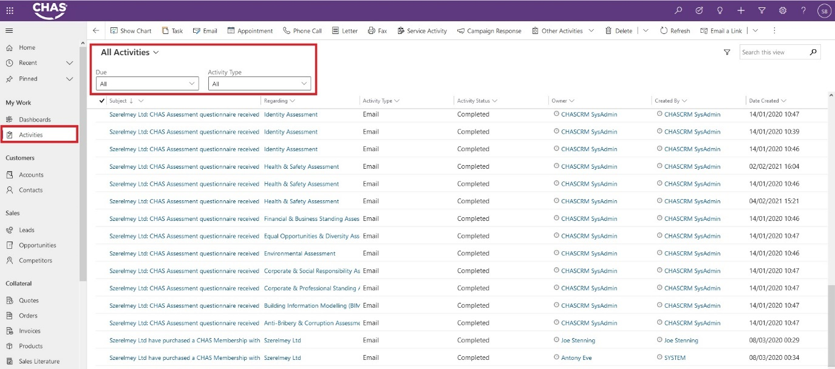

Figure 6: Example activities form

Highlighted sections show how to navigate to the Activities section, as well as different filters that can be done:

My Activities: The ability to change a view of activities based on specific filtered criteria.

Due: The ability to filter out activities due within a certain time period

Activity type: The ability to filter different types of activities.

Using the above you can easily filter out to show all my Teams tasks due in the next 7 day (Defined where I am their manager):

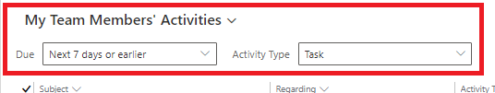

At current usage, Crimson recommends CHAS use the above activity types defined rather than just phone calls. Similarly for timelines, Crimson recommends utilising out of the box capabilities for Click Dimensions (detailed in section 8.0) that will not overpopulate timeline activities news feeds as in current state set up.

## Business Process Flows

Business Process Flows (BPF) is a function within Dynamics 365 that allows any user to enter data in a consistent manner and to add control gates, ensuring that users cannot progress, for example, an enquiry, without having all relevant information captured and detailed.

This is an example of how Lead conversion to Opportunity on Business Process flow could look for CHAS. Again, this screenshot is purely shown as an example of how a BPF could work. All fields, control gates and requirements would be defined as the project progresses.

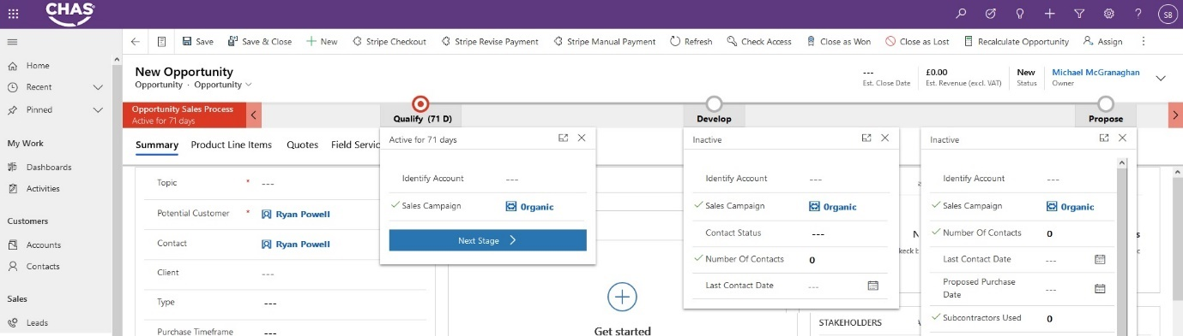

Figure 7: opportunity business process flow

During the HLD workshops we discovered there was a need to harmonise language and approach to BPFs to streamline the sales process. The following is this initial output of this unified sales process effort across clients and contractors.

It must also be noted that for BPFs, Crimson would usually look at defining BPFs as each entity is built out and completed, (e.g. Lead Entity, Opportunity Entity) and are usually created to strengthen and reinforce the ‘To Be’ process.

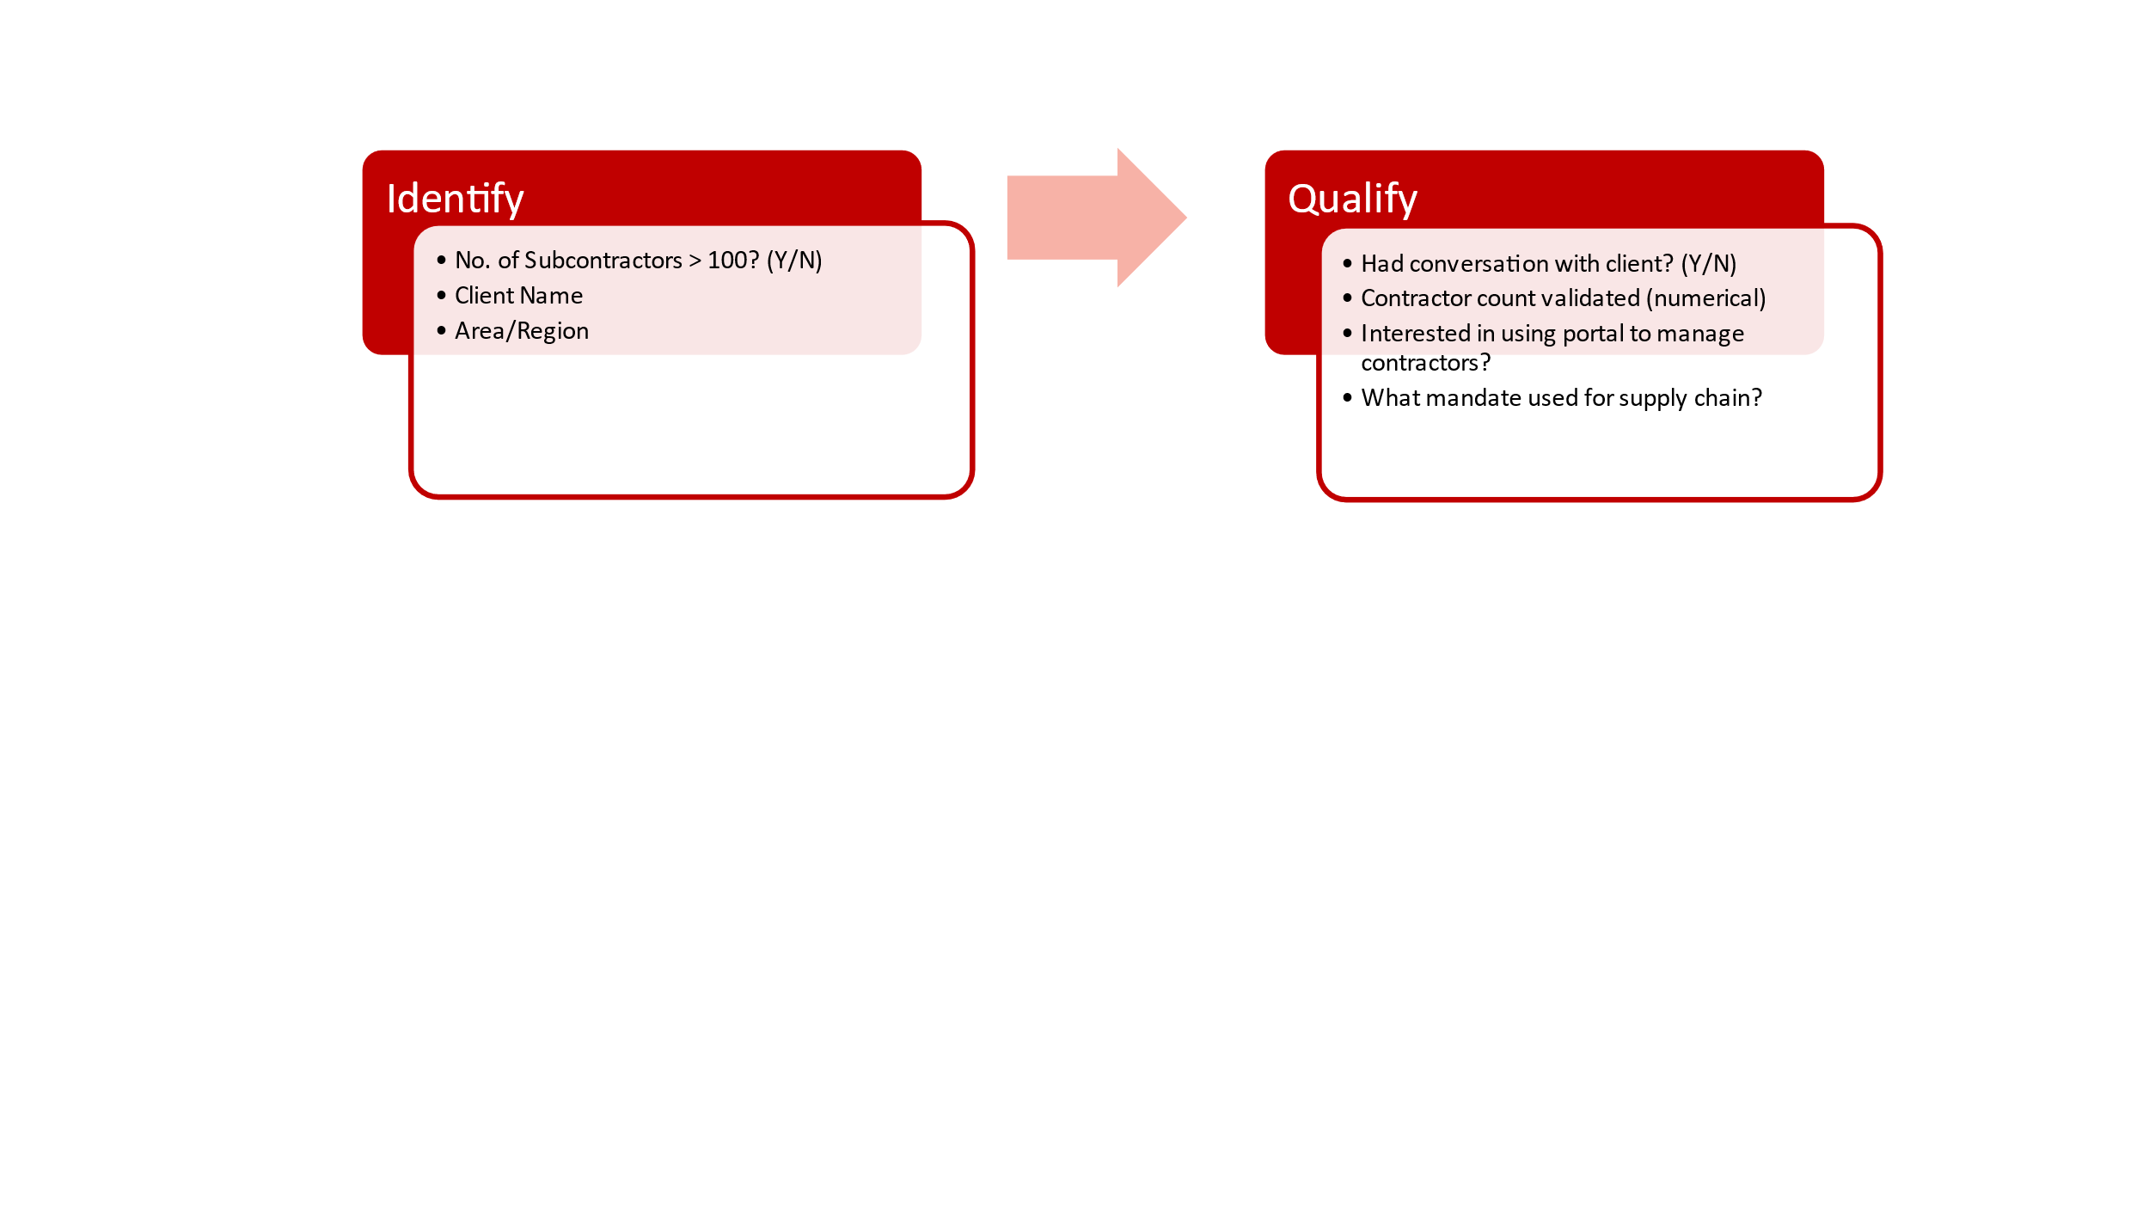**Lead Entity BPF Process for Clients:**

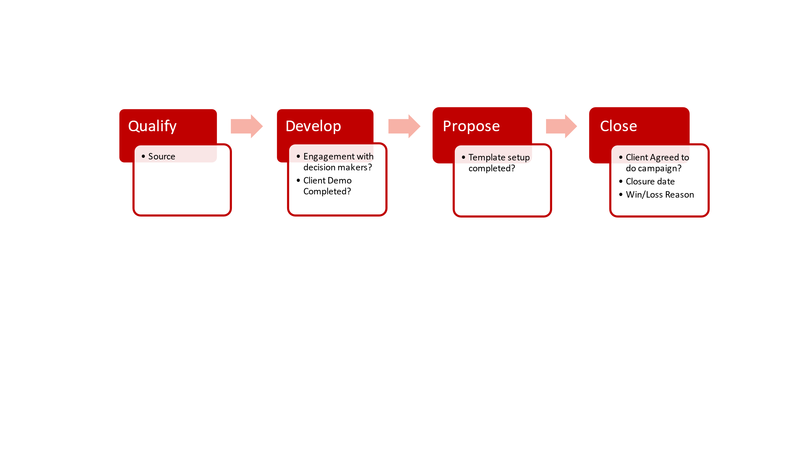**Opportunity Entity BPF Process for Clients:**

**Lead Entity BPF Process for Contractors:**

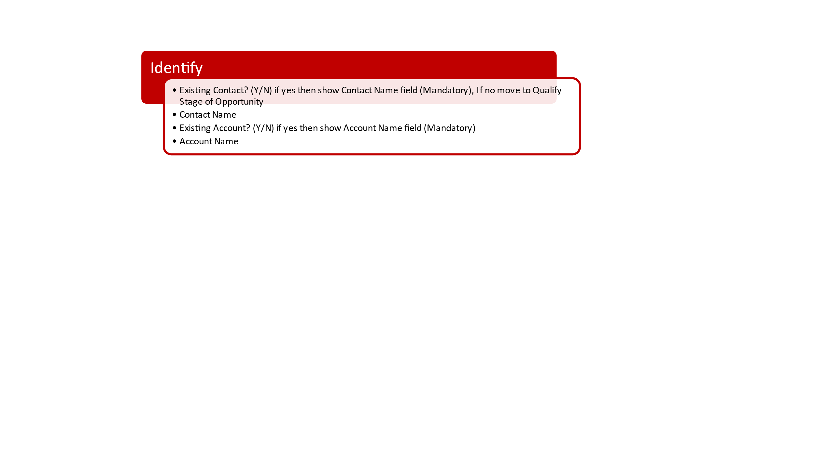

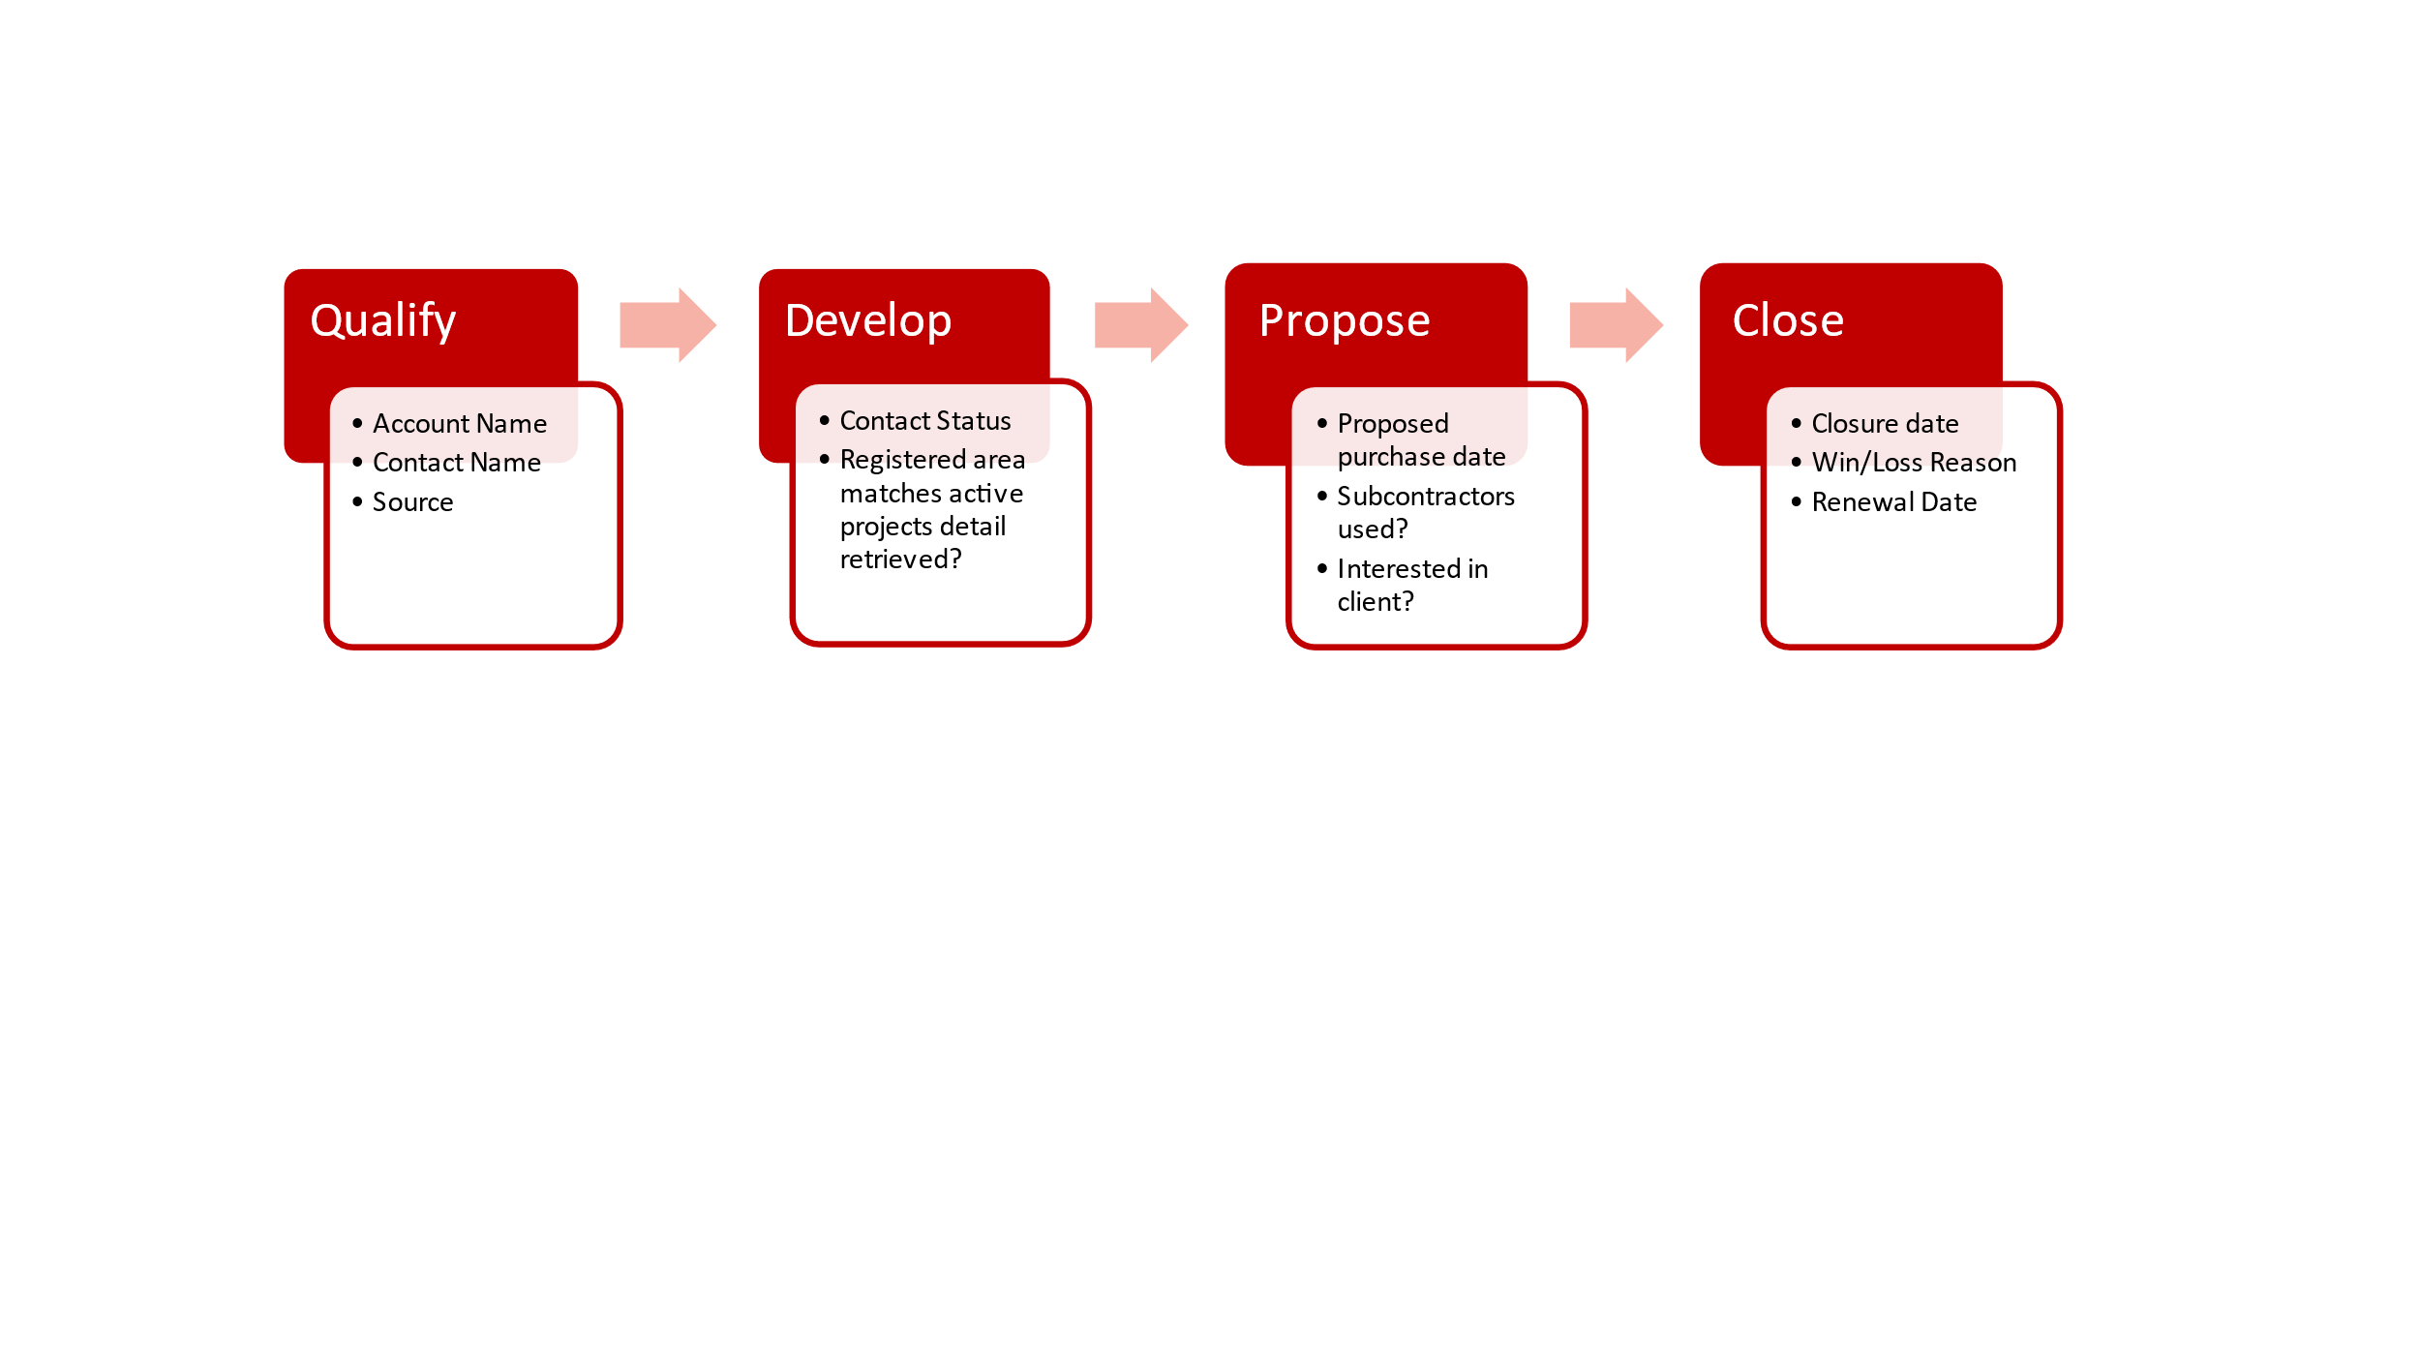**Opportunity Entity BPF Process for Contractors:**

As detailed, Crimson recommends a harmonised approach to managing Clients and Contractors both in Lead and Opportunity process. This unified approach not only simplifies sales process across the two client types but also will allow CHAS to produce 360-degree view reporting of all Clients and Contractors for true value add management information, whilst ensuring common language through the two sales teams and the wider CHAS group.

# Summary

This is the high-level summary of the CHAS CRM Form Customization Implementation for Sales and Marketing Phase 1.